**A Study on International Business Strategy and Operations of Tesla**

**Submitted to:**

*Dr. Prabir Chandra Padhy*

*Submitted By*

Sriyashree Padhy 19BCE2356

Alokam Nikhitha 19BCE2555

Harshit Mishra 19BCE0799

Devarsh Shah 19BCE0563

Janesh Patel 19BCE0631

Kanani Harsh Dhirajlal 19BCE2562

**MGT1031 – International Business**



April, 2022

**TABLE OF CONTENTS**

|  |  |  |
| --- | --- | --- |
| **Chapter No.** | **Title** | **Page No.** |
| **0** | **List of Figures** | IV |
| **1** | Executive Summary | 1 |
| **2** | Introduction | 1 |
| **3** | **Focus of Study** |  |
|  | 3.1 Business Model | 2 |
|  | 3.2 Technologies | 2 |
|  | 3.3 Key Policies | 2 |
| 4 | **About the Company** | 3 |
| 5 | **SWOT Analysis** |  |
|  | **5.1 Strengths** |  |
|  | *5.1.1 A Top Employer Company* | 4 |
|  | *5.1.2 Most Valuable Automobile Firm* | 4 |
|  | *5.1.3 Best-in-class Electric Cars* | 4 |
|  | 5.1.4 Better Positioned | 5 |
|  | **5.2 Weaknesses** |  |
|  | *5.2.1 Manufacturing Complications* | 5 |
|  | *5.2.2 Battery Shortage* | 5 |
|  | *5.2.3 One-Man-Show* | 5 |
|  | *5.2.4 Financial Uncertainty* | 5 |
|  | **5.3 Opportunities** |  |
|  | *5.3.1 New Market* | 6 |
|  | *5.3.2 Cheap Costs* | 6 |
|  | *5.3.3 Battery Production* | 6 |
|  | *5.3.4 Air Taxis* | 6 |
|  | **5.4 Threats** |  |
|  | *5.4.1 Liability* | 7 |
|  | *5.4.2 Extensive Competition* | 7 |
|  | *5.4.3 Product Defects* | 7 |
|  | *5.4.4 Absence of Regulations* | 7 |
| **6.** | **Competitive Strategies** | 8 |
| **7.** | **Literature Review** |  |
|  | 7.1 Business Model | 8 |
|  | 7.2 Business Model Canvas | 9 |
| **8.** | **Problem Statement** | 10 |
| **9.** | **Objectives** | 10 |
| **10.** | **Resources Hypotheses** | 11 |
| **11.** | **Research Methodology** | 11 |
| **12.** | **Data Collection** | 12 |
| **13.** | **Dissemination of Results** | 12 |
|  | 13.1 Hypothesis 1 result | 13 |
|  | 13.2 Hypothesis 2 result | 13 |
| **14.** | **Interpretation** | 14 |
| **15.** | **Findings** | 15 |
| **16.** | **Suggestions** | 17 |
| **17.** | **Beneficiaries** | 18 |
| **18.** | **Conclusions** | 19 |
| **19.** | **Bibliography** | 20 |

**LIST OF FIGURES**

|  |  |  |
| --- | --- | --- |
| **Figure No** | **Figure Name** | **Page No** |
| **1.** | Logo of Tesla | 3 |
| **2.** | Tesla’s Business Model Canvas | 9 |
| **3.** | Tesla’s Annual Revenue | 16 |
| **4.** | Tesla’s Electric Rise in Value | 16 |
| **5.** | Norway Auto Registration (February 2020) | 17 |

**1. Executive Summary**

International Business help us in understanding on how globalization has made a great impact on the connection of people, organizations ,markets and also the information across the borders. It contributes to a better grasp of global marketplaces. It not only helps us gain that necessary business acumen but also helps us understand how different countries operate when it comes to business of foreign companies in their country.

Studying international business policies of an established firm and their operations helps in understanding how an organization works on an international basis and how their operations differ from country to country in order to expand their business.

In this work, we are going to study international business strategies and policies of a very successful international firm named *Tesla.* This work will help us gain the mentioned insight of operating an international business and will also help us understand as to how an automotive industry operates and produces its end product in foreign markets.

**2. Introduction**

Tesla is an automotive industry which is founded in year 2003 by Elon Musk, Ian Wright, Martin Eberhard, Marc Tarpenning and B Straubel. Tesla's business strategy relies around creating and producing electric vehicles and solar panels through its solar city subsidiary. It is the world's leading maker and supplier of plug-in vehicles. Tesla’s revenue model is based on many services such as Tesla Motor Vehicles, Energy Storage, Solar Panel, Retail Merchandise, Auto Service etc. Tesla Business Model is a Direct-to-Consumer  business model since it sells directly to consumers, eliminating intermediaries like as dealerships and providing its own charging station network. Tesla's income is derived from the selling model, service, and charging network. In addition, it implemented a business model practically unique in its area, by selling directly to the consumer, without middlemen.

**3. Focus of Study**

The 3 main aspects of Tesla that we have focused in the paper are -

* Business Model
* Technologies
* Key Policies

**3.1 Business Model:**

We wanted to understand the core business model of Tesla and what all marketing strategies does it employ when it comes to establishing its business in different countries.

Understanding the business model of Tesla would give us an insight not only on working of an automotive company but also working of an establish D2C brand as the end user here is a direct customer rather than selling through a conventional automotive franchise model.

**3.2 Technologies:**

Being students of Computer Science and Engineering background, we wanted to take this opportunity of studying tesla and finding our what amazing technologies is Tesla currently working on and what new things does it plan to incubate in the near future.

Tesla is known for rapid innovations in field of data science and effective productions. Understanding these technologies will not only make us familiar with next world products, but will also help us add this information to our skillsets.

**3.3 Key Policies:**

Finally, we wanted to created a list of Tesla’s key policies and business ethics. It is no brainer that a company which has gained such an immense popularity in this little time, must be having a set of detailed ethic runs that it must abide by. Not only this, we wanted to understand what actually makes this company such a big name which it holds today.

**4. About the Company**

Tesla is an automotive company. It is an American automobile and sustainable energy firm headquartered in Austin, Texas. It designs and manufactures best in class electric vehicles, known for their safety, performance and looks. Tesla also operates in fields of battery energy storage from home to grid-scale and solar roof tiles, and related products and services. It is founded in year 2003 by Elon Musk, Ian Wright, Martin Eberhard, Marc Tarpenning and B Straubel. It aims at making earth a green planet and move towards sustainable, low emission alternatives over fossil fuel vehicles.

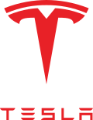

**Fig 1. Logo of Tesla**

The executive leadership of Tesla is as follows:

Robyn M. Denholm - Independent Chairman of the Board

Elon Musk - Chief Executive Officer and Director

Zachary Kirkhorn - Master of Coin and Chief Financial Officer

Andrew D. Baglino - Senior Vice President

Kimbal Musk - Director

Tesla, Inc. creates, develop, produces, sells and leases electric automobiles, as well as energy generating and storage systems, and provides associated services. Two of the company's segments are automotive and energy generation and storage. Design, development, production, sales, and leasing of electric cars, as well as the sale of automotive regulatory credits, are all part of the automotive industry.

**5. SWOT Analysis**

**5.1 Strengths**

***5.1.1 A Top Employer Company:***

Any association is just as great as individuals who work for it. On account of Tesla Inc., it is one of the essential explanations behind the organization’s uncommon achievement. Tesla has arisen as an optimal organization for representatives because of its assorted and creative culture. It was as of late named probably the best work environment, drawing in youthful work searchers with new abilities and energy. Tesla is known for having one of the best employer environments across the industry and values its employees with at most care and respect. The work culture in Tesla also seems to be stress free and the employees of the company boast about it.

***5.1.2 Most Valuable Automobile Firm:***

Not with standing its concerns, Tesla’s income in the financial year 2021 was *$53.8 billion,* with 936,172 vehicles conveyed to clients. The expansion in conveyances and its $5.6 billion benefit expanded the organization’s market capitalization to more than *$1 trillion,* outperforming the market capitalization value of the main five automakers, Toyota, Volkswagen, Daimler, Ford and General Motors consolidate.

***5.1.3 Best-in-class Electric Cars:***

Tesla has outperformed each and every brand in the competition to create the best electric vehicles. With regards to go, Tesla’s electric vehicles have shown to be the most incredible concerning covering the best distances. As indicated by a new correlation, Tesla positions first, second, and third with regards to go. The Tesla Model S, will take you the farthest, with a solitary battery charge permitting you to make a trip as much as 600 kilometres in one charge. The nearest contender to this model is Opel Ampera, which has a scope of 520 kilometres.

***5.1.4 Better Positioned:***

It is believed by many experts that Tesla is better positioned to weather economic uncertainty than other US automakers. For example, Tesla’s revenue increased to *$53 billion in 2021,* and the company delivered more than 900,000 cars by the end of 2021, more than doubling its output in 2020.

**5.2 Weaknesses**

***5.2.1 Manufacturing Complications:***

The higher the norm of advancement, the more prominent will be mechanical inconveniences and creation risk factors. Tesla faces nonstop send off, assembling and creation incline delays for their new vehicles.

***5.2.2 Battery Shortage:***

In the yearly investor gathering, CEO Elon Musk acknowledged that their creation rate has diminished because of the restricted stockpile of batteries. This has directly showed impact on the deals of electric vehicles.

***5.2.3 One-Man-Show:***

Elon Musk is the company's public face. Sadly, Elon Musk has a lot on his shoulders to give his 100% to the company. Musk is also deeply involved in other projects like space launch vehicles at Space Exploration Tech Corporation and The Boring Company.

***5.2.4 Financial Uncertainty:***

Colossal monetary capacities permit organizations to vie for piece of the pie all the more actually. Tesla has an obligation of $5.38 billion. Any deferral in reimbursing could raise the gamble of postponing development, decrease in deals and result in short-term collapse of the company’s whooping growth.

**5.3 Opportunities:**

***5.3.1 New Market:***

Tesla is competing in a market that has yet to be identified.The main chance for the organization currently is the Asian market, which is as yet unsaturated in the field of electric cars and environmentally friendly power market.

***5.3.2 Cheap Costs:***

In spite of the fact that Tesla is costly because of its unpredictable dependence on development, they have sent off the Model 3, which is a more reasonable adaptation of the Model S with less reach, power, and less elements, but is truly manageable and resourceful.

***5.3.3 Battery Production:***

Tesla can involve this chance of absence of batteries in unfamiliar business sectors and acquire the battery creation innovation house. This wont just gives a less expensive option, however will likewise give a more up to date aspect to their selling choices.

***5.3.4 Air Taxis:***

Interest for creative metropolitan air-taxi administrations to override customary cabs and lessen gridlock and contamination is projected to increment definitely by 2025. Tesla has skill in eVTOL vehicles and can involve it as an open door.

**5.4 Threats**

***5.4.1 Liability:***

Regardless of Tesla's superior quality confirmation, the car business is acclimated with confronting huge item responsibility claims which the organization fears to be one of the greatest monetary blows.

***5.4.2 Extensive Competition:***

Tesla Inc. faces forceful rivalry from both electric fuel vehicles and self-driving tech. Numerous auto brands in the extravagance section give choices to economy fragments also. Since, fossil fuel powered cars are much cheaper, it is a truth that many would prefer them over Tesla’s electric and environmentally friendly vehicles. Not only this, Tesla is no longer going to be a monopoly when it come electric vehicles because Apple and Mercedes are planning to enter this business.

***5.4.3 Product Defects:***

Because of profoundly complex designing for inventive vehicles, Tesla's vehicles and other energy items have shown significant defects by and large. The deficient items frequently have powerless plans, fabricating and so forth and damage the picture of Tesla.

***5.4.4 Absence of Regulations:***

As there could be no appropriate guidelines for self-driving in numerous nations, including the US, Tesla's deal is impacted by oneself driving limitations in numerous areas. This befuddling circumstance increments lawful intricacy in later endeavours.

**6. Competitive Strategies**

Tesla's cutthroat methodology in the car business is an expansive separation that objectives both premium and low-cost purchasers. In view of that nonexclusive system, Tesla separates itself from contenders by expanding its R&D speculation many years to foster an exceptionally imaginative, unique environment for expanding monetary returns.

In view of the presentation of the Tesla Model 3, Tesla is right now seeking after an expansive separation methodology. The Model 3 rival’s different vehicles in the medium size car market, with a beginning MSRP of $35,000, inferring that Tesla is endeavouring to interest the overall vehicle purchasing public.

A broad differentiation methodology's essential angles incorporate limiting the functional costs of the item, including actual characteristics that enticement for purchasers, and communicating the worth of an organization's items to expected clients.

**7. Literature Review**

**7.1 Business Model**

Since the business model was put forward in the 1950s, people from all walks of life have had a heated discussion on the business model. As the business model is constantly changing, there is still no consensus on understanding the business model. The business model is mainly used to solve strategic problems in companies, which is determined by two main factors: efficiency and novelty. At the same time, as a centre, the business model is constantly squeezed by strategy, organization, and system. Of course, it is also suggested that the core of the company’s business model should not be based on untested or speculative assumptions about the future. The business model mainly refers to three aspects: company logic, company operation mode, and how to create value for stakeholders.

**7.2 Business Model Canvas:**

The business model canvas was first proposed by Osterwalder. Business model canvas can be divided into four categories: Product, Customer Interface, Infrastructure Management, and Financial Aspects. And these four categories include a total of nine subcategories: Customer Segments, Customer Relationship, Channels, Key Partners, Key Activities, Key Resources, Value Propositions, Cost Structure, and Revenue Streams. These are nine interrelated factors, and the aspects expressed by these nine factors are also different. Business model canvas is a tool, which provides the company with the goals it needs to achieve, and analyses the strategic elements that have the greatest impact on the business. We mainly use the business model canvas to study the business model of Tesla.

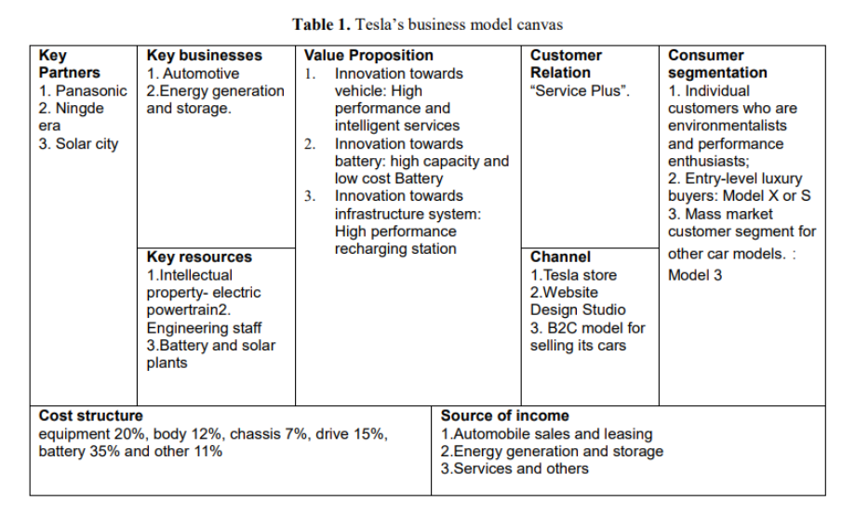

**Fig 2: Tesla’s Business Model Canvas**

**8. Problem Statement**

We define our problem statement as *“To Study the international business policies of Tesla, so as to understand what makes it so successful. Then use the above gained knowledge to educate ourselves, either for our position in a corporate world or in our own future business ventures”*.

**9. Objectives**

1) The main objective of this project is to understand International Business Policies of an established Multination Company, which is Tesla in our case. All successful modern businesses are international. Trading in countries around the world, and having bases in as many different places as possible, opens up new possibilities.

2) Being students in Bachelors of Technology we will most probably find ourselves in such a technology-based multinational company. We wanted to develop our business acumen, so that our varied input apart from expertise in technology, would help us ace our position.

3) Apart from these, we could use this knowledge to set up our own business endeavor. Having a broad knowledge of business and the benefits of internationalization will make us a valuable acquisition for any business, be it nay other company that we would be working for, or our own venture.

4) Thus, this project all in all will help us gain better insight on core functioning and market modelling of successful companies. Apart from this we might find some by-product gains from this project, which could include better business analytics, human resource management, marketing knowledge, product management and procurement procedures.

**10. Resources Hypotheses**

*Hypotheses 1:* After implementing the necessary changes to its business policies, Tesla will be able to set-up its business in India.

*Null Hypotheses:* After implementing the necessary changes to its business policies, Tesla won’t be able to set-up its business in India.

*Hypotheses 2:* After new entrants of automobile giants, Tesla will still be able to maintain its monopoly.

*Null Hypotheses:* After new entrants of automobile giants, Tesla won’t be able to maintain its monopoly.

**11. Research Methodology**

We would like to propose the idea of gaining information from as many resources as possible. We have looked through the internet and found that we could gain some facts directly from there. Facts on the internet are not only specific to International Business Policies of Tesla but are also about the company in general and its market strategies. We would like to include all this in this project report. Apart from this we would like to mail a questionnaire to the concerned authorities at Tesla about this academic attempt of ours and would like to gain a few points from there if they allow us to do so. The list of questions would include all the questions which were left unanswered after our web searching and pruning. These are the two core methodologies that we plan on employing for the project. On a minor basis we would also like to gain insight from the company’s profile on professional platforms like LinkedIn.

**12. Data Collection**

The goal of data collecting is to gather high-quality evidence that can be analyzed to produce persuasive and reliable answers to the questions that have been unanswered. We want to learn more about Tesla’s foreign business strategy, as well as its operations and other policies that have helped it become the hugely successful corporation it is today. We are studying about the company, its goods, and why they're so popular today, as well as its policies and business strategy, in order to gain a better understanding of the firm and its growth trajectory. To completely achieve this, we have planned to send a questionnaire to Tesla's relevant authorities, outlining some of our concerns about their policies and commercial actions. Based on all of this, we'd be accumulating all of this information and keeping it in mind for any future company ventures. Earlier we collected information from as many web sources as possible. We went on the internet and discovered the data and the information present there. But those facts on the internet are not particularly specific to Tesla's international business policies. All of this is something we'd like to put in our project report. So, we planned to collect data by sending a questionnaire to Tesla's relevant authorities on our academic endeavour, and we'd like to acquire a few points if they allow us to do so. All of the queries that were left unanswered after our online research and trimming would be included in the list of questionnaires. This is the primary data collection approach that we are intended to use for the project.

**13. Dissemination of Results**

Tesla is without a doubt a disruptor in the automotive industry. The company is reinventing the way cars and technology interact, bringing a sustainable and energy-efficient transportation solution to its customer. Given the current global climate scenario, we must reduce emissions and begin contributing to climate change. The Pew Research Centre Reports that 88 percent of all Americans own a car. Electric vehicles have the potential to be a game changer int the global warming crisis.

Given the significance of Tesla’s innovative technology and the brand’s impressive popularity, the company continues to see a high demand for its product, and it needs to improve its logistics and supply chain processes in order to being delivering its products on time.

Tesla is an enthralling company with one-of-a-kind products and a significant environmental impact. If the company wants to maintain its position as the world’s *“most-loved automotive brand”*, it must address its inventory and supply chain issues.

**13.1 Hypothesis 1 result:**

The Indian government has approved 4 models of Tesla. Hence, it is legal in India to buy, sell, and drive Tesla cars. As it seems, Elon Musk have problems with high import duties being leveraged at automotive cars. On governments side, they have stated that *Tesla is putting pressure on government officials to recess the import duties.*

Government have also advised Tesla to deploy a CKD (Complete Knock Down) Method to get rid of import duties. According to it, there is no excise on importing parts of auto-cars in India. So, tesla can import parts in India and set-up its assembly line in India to avoid paying any Tax.

Elon Musk have denied the use of any such method to expand Tesla in India. According to him, tesla wants to have a pilot run instead. They want to know how adaptive will Tesla cars be in India and if it is actually profitable to set-up its assembly line in India. Only if the conditions are met, they will think about setting up the assembly line.

So, our perception to this situation is that, Tesla can easily employ the government devised methodology and set-up its business in India without any troubles. Hence, we ***accept our hypotheses and reject the null hypotheses.***

**13.2 Hypothesis 2 result:**

Apple and Mercedes have announced that they will be entering this segment of Electric vehicles soon enough. Not only this, in India itself we have a whooping number of start-ups that aim at this technological gain and consolidate their first mover advantage in Indian Markets. In our findings we were not clearly able to differentiate if Tesla would actually be able to still continue in Broad Differentiation category by the time its set-up its business in Asia. Also, if companies from Japan and Korea like Honda, Hyundai etc. plan on joining this segment, it will be really difficult of Tesla to still maintain its monopoly in Asian market, because these company have cracked the nerves of Asian Populations.

Although, Tesla is known for extensive research and development inventory. It is a no brainer that company has this advantage over other companies in auto industry. Clearly, it will be able to surpass the performance of these new entrance and continually be able to maintain that edge of performance over other companies.

So, our perception to this situation is that, Tesla may or may not be able to maintain its monopoly, but will definitely enjoy a big percentage of market share despite the entry of new entrants. Hence, we ***neither reject nor accept our hypotheses.***

**14. Interpretation**

Tesla is a major player in the automotive industry, especially with the innovations that it brings to the table. Its electric car is a major game changer in the industry, given the focus on green energy and global warming crisis these days. This has caused the brand to rise not just in popularity, but also commercially. Still, there is a scope for improvements, especially in the logistics processes as has been mentioned earlier. Tesla’s success was measured on 3 metrics, wherein it was finally concluded that the strategy it employs have been successful in not only raising brand awareness and popularity, but also have led to huge profit margins.

**15. Findings**

1) Elon Musk started Tesla Motors, Inc., a unique and innovative automotive firm. Tesla is credited with transforming the public’s image of electric vehicles. Tesla has demonstrated via innovation that it is possible to develop vehicle that combines speed, luxury, and environmental features while remaining inexpensive. Tesla’s Model S and Model X are the future’s response to how the globe will power sustainable energy and innovation.

2) Tesla’s vehicle are high-performance luxury sedans that are totally electric. It differs from its predecessor in that it has a basic price that is less tha half that of its predecessor. The Model S and Model X may be marketed to a bigger target population than ever before, with prices ranging from $68,400 to $135,500 in the premium car class. Males between the ages of 25 and 60 who live in metropolitan areas and have an annual household income of more than $100,000 were designated as the target market. They are also technologically smart and environmentally sensitive. Tesla's initial paid advertising campaign, as well as a number of promotional approaches, were chosen to target this segment.

3) "We do not inherit the earth from our forefathers; we borrow it from our offspring," was a powerful slogan used to promote the Model S. The target market was drawn to this message because of its emotional and moral appeal. The message was communicated through print media since it was thought to be the most effective approach to target the target market while also being the most cost-efficient in compared to other forms of advertising. The magazines Car and Driver, Wired, Business Week, and Forbes were chosen because their readers represent the Model S' target market.

4) Three metrics were used to assess the strategy's success. The first is the number of queries regarding the automobile from consumers. The second category includes the number of people that visit Tesla dealerships to test drive the Model S and X. The third factor was the number of vehicles sold between the start of the ad campaign and the subsequent 12 months. The ad campaign began in the fall of 2012 and will end in January of 2013. Tesla expected to sell 20,000 units in 2013, and meeting that target was critical to the plan's success.

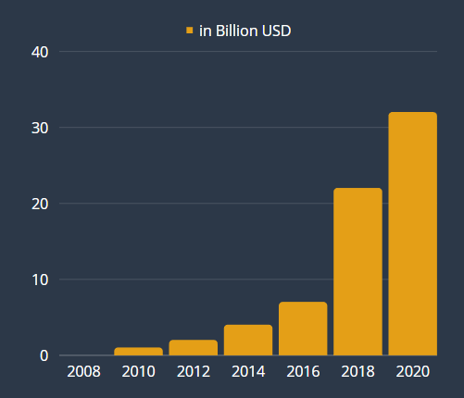

**Fig 3: Tesla’s Annual Revenue**

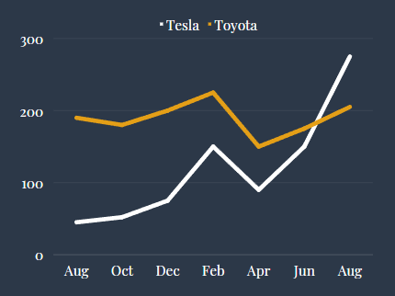

**Fig 4: Tesla’s Electric Rise in Value**

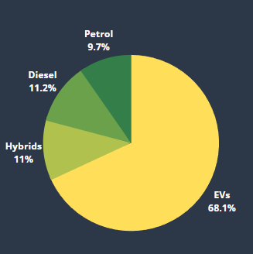

**Fig 5: Norway Auto Registration (February 2020)**

**16. Suggestions**

1) Tesla should attempt to become the top or one of the leading makers of EVs as a provider for this market, with EV sales expanding and continuing to rise at a quick pace.

2)Furthermore, many of the United States' core states have few to no charging outlets and a poor knowledge of electric vehicles. More Supercharger stations in these places, as well as more in the areas of their top sales, are areas where the firm should really strive to focus some of their funding.

3) Additionally, adding additional advertising will raise knowledge of their car and the distinct benefits they offer in comparison to other companies in the industry.

4) In addition, they are broadening their product line to appeal to a wider spectrum of customers, particularly low-income ones. With their current market position, Tesla is easily capable of overtaking the market and implementing their general desire for innovation as well as a safer and cleaner planet through the shift to EVs. Whenever one of their competitors offered an incentive or a supplement to their hybrid or electric vehicle, Tesla anticipated the move and prepared for it. Every plan of action devised was well-considered, well-funded, and vital for the corporation to implement in order to improve their products and outperform their competition. With so many options, possibilities, and incentives available, Tesla should have no trouble attracting new consumers, especially once the Model 3 is priced much lower. When compared to hybrid and internal combustion engines, completely electric vehicles have a higher price elasticity. Because electric vehicles are not as popular as many people believe, they are incredibly adaptable. The most typical vehicle that people think of when they hear the term "electric vehicle" is a hybrid. Furthermore, Tesla's manufacturing is solely dedicated to EVs, with the goal of providing a luxury EV at an affordable price. While demand for Tesla's products is flexible, supply is generally rigid. Tesla has adequate resources and demand predictions to work through the losses it is experiencing and continue to supply its automobiles to customers.

5) Finally, Tesla Motors should emphasize its green technology nature and the environmental consequences of electric vehicles, and so advocate for a government policy plan that will help EV companies grow.

**17. Beneficiaries**

Tesla is, as you may know, one of the market leaders in the sector of electric vehicles, battery-based storage, as well as related technologies and advances. The people of our own country, our companies and organizations including the Indian government would benefit from Tesla being able to enter into the Indian market. If Tesla begins production in India, India has a plethora of creative thinkers who would be well-served. It also means that India might become Tesla's Asian manufacturing base. As a result, Indians would be able to afford the same automobile as their Asian counterparts. This will also help India's domestic sales. The company is seeking critical electrical, electronic and mechanical components, also it is seeking people familiar with this matter. The parts include instrument panels, windshields, differential brakes, gears and power seats, the paper said. Sona Comstar Ltd., Sandhar Technologies Ltd. and Bharat Forge Ltd. can be among major beneficial Indian companies for supplying components to Tesla. Due to the Make in India campaign, obtaining all of the parts locally will further cut expenses. And, even when sold to other nations, the overall cost may be considerably lower than it is currently. India is now dealing with a massive pollution crisis that has gone mostly unnoticed. This must be handled and resolved as soon as possible. Someone needs to make a huge splash here and break the ice. The direct sales approach is likewise fantastic and should be emulated by everyone. The earnings are being eaten away by middlemen (dealers). We frequently wind up with a lower-quality product for a higher price. Tesla is an excellent illustration of how things should be done in this situation. The same may be said for company-owned service centers. Take a look at how satisfied your customers are. Only company-owned service stations are capable of doing this. Unfortunately, all of them are franchised by other automakers. Which needs to be altered and that is possible with the entry of Tesla in the Indian market.

**18. Conclusions**

Tesla was formed in 2003 by a group of engineers who wanted to show that driving electric vehicles doesn't have to be a compromise - that they can be better, faster, and more fun to drive than gasoline cars. Tesla now manufactures not only all-electric automobiles, but also renewable energy generating and storage systems that are infinitely scalable.

The company combines automation and artificial intelligence to provide its customers with unique and top-notch cars. This, combined with its business strategies, is the reason why Tesla’s position in the automotive industry is undisputed.

While its technical prowess is unmatched, the issues that the company is facing while trying to set up business in India is our main area of focus. We also focus on the business policies it employs in different countries to expand its reach and maximize profits.

**19. Bibliography**

[1] <https://www.researchgate.net/publication/327120579_Marketing_Research_on_Tesla_Inc_it%27s_products_and_strategies>

[2]

<https://www.livemint.com/companies/news/tesla-has-another-setback-in-india-now-what-11643963712567.html>

[3]

<https://www.tesla.com/blog/secret-tesla-motors-master-plan-just-between-you-and-me>

[4]

<https://alecfurrier.medium.com/tesla-business-model-strategic-analysis-c7d00bdc0339>

[5]

<https://www.investopedia.com/articles/active-trading/072115/what-makes-teslas-business-model-different.asp>

[6]

<https://research-methodology.net/tesla-business-strategy-relentless-focus-on-sustainable-energy/>

[7]

<https://www.startingbusiness.com/blog/business-strategy-tesla>

[8]

<https://www.business-standard.com/article/international/tesla-in-talks-with-indian-firms-for-auto-components-says-report-121082900154_1.html>